**Lab: Introduction to AWS IAM**

**AWS Identity and Access Management (IAM)** is a web service that enables Amazon Web Services (AWS) customers to manage users and user permissions in AWS. With IAM, you can centrally manage **users**, **security credentials** such as access keys, and **permissions** that control which AWS resources users can access.

**This lab work on only Free Tier account**

**For all the 3 users you create, create a password by going into username -> security credentials -> enable console access -> and set a custom password**

**Please provide below screen captures**

* **Steps 11,32,41,49 and 51.**

**Topics covered**

This lab will demonstrate:

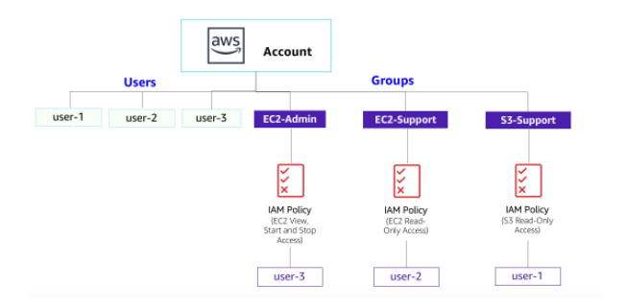

* Exploring pre-created **IAM Users and Groups**
* Inspecting **IAM policies** as applied to the pre-created groups
* Following a **real-world scenario**, adding users to groups with specific capabilities enabled
* Locating and using the **IAM sign-in URL**
* **Experimenting** with the effects of policies on service access

**Other AWS Services**

During this lab, you may receive error messages when performing actions beyond the steps in this lab guide. These messages will not impact your ability to complete the lab.

**AWS Identity and Access Management**

AWS Identity and Access Management (IAM) can be used to:

* **Manage IAM Users and their access:** You can create Users and assign them individual security credentials (access keys, passwords, and multi-factor authentication devices). You can manage permissions to control which operations a User can perform.
* **Manage IAM Roles and their permissions:** An IAM Role is similar to a User, in that it is an AWS identity with permission policies that determine what the identity can and cannot do in AWS. However, instead of being uniquely associated with one person, a Role is intended to be *assumable* by anyone who needs it.
* **Manage federated users and their permissions:** You can enable *identity federation* to allow existing users in your enterprise to access the AWS Management Console, to call AWS APIs and to access resources, without the need to create an IAM User for each identity.

**Duration**

This lab takes approximately **40 minutes** to complete.

**Accessing the AWS Management Console**

1. At the top of these instructions, click Start Lab to launch your lab.

A Start Lab panel opens displaying the lab status. In the **Start Lab** dialog box that opens, note the AWS Region, as you will need to refer to it later in this lab.

1. Wait until you see the message "**Lab status: ready**", then click the **X** to close the Start Lab panel.
2. At the top of these instructions, click AWS

This will open the AWS Management Console in a new browser tab. The system will automatically log you in.

**Tip**: If a new browser tab does not open, there will typically be a banner or icon at the top of your browser indicating that your browser is preventing the site from opening pop-up windows. Click on the banner or icon and choose "Allow pop ups."

1. Arrange the AWS Management Console tab so that it displays along side these instructions. Ideally, you will be able to see both browser tabs at the same time, to make it easier to follow the lab steps.

**Task 1: Explore the Users and Groups**

In this task, you will explore the Users and Groups that have already been created for you in IAM.

1. In the **AWS Management Console**, on the **Services** menu, click **IAM**.
2. In the navigation pane on the left, click **Users**.
3. Click **awsstudent**. (**YOU CAN CREATE THIS USER, make sure to give the custom password after enabling console access**)

This will bring to a summary page for awsstudent. The **Permissions** tab will be displayed.

1. Notice that awsstudent does not have any permissions.
2. Click the **Groups** tab.

**awsstudent** also is not a member of any groups.

1. Click the **Security credentials** tab. (**SKIP THIS**)

awsstudent is assigned a **Console password**

1. In the navigation pane on the left, click **Groups** and create the below groups
   * EC2-Admin (**Attach Permissions and Give [AmazonEC2FullAccess](https://us-east-1.console.aws.amazon.com/iamv2/home?region=us-east-1#/policies/details/arn%3Aaws%3Aiam%3A%3Aaws%3Apolicy%2FAmazonEC2FullAccess)**)
   * EC2-Support(**Attach Permissions and Give [AmazonEC2ReadOnlyAccess](https://us-east-1.console.aws.amazon.com/iamv2/home?region=us-east-1#/policies/details/arn%3Aaws%3Aiam%3A%3Aaws%3Apolicy%2FAmazonEC2ReadOnlyAccess)**)
   * S3-Support(**Attach Permissions and Give [AmazonS3ReadOnlyAccess](https://us-east-1.console.aws.amazon.com/iamv2/home?region=us-east-1#/policies/details/arn%3Aaws%3Aiam%3A%3Aaws%3Apolicy%2FAmazonS3ReadOnlyAccess) **)

1. Click the **EC2-Support** group.

This will bring you to the summary page for the **EC2-Support** group.

1. Click the **Permissions** tab.

This group has a Managed Policy associated with it, called **AmazonEC2ReadOnlyAccess**. Managed Policies are pre-built policies (built either by AWS or by your administrators) that can be attached to IAM Users and Groups. When the policy is updated, the changes to the policy are immediately apply against all Users and Groups that are attached to the policy.

1. Under **Permissions**, click on the Policy Name and then click JSON.

A policy defines what actions are allowed or denied for specific AWS resources. This policy is granting permission to List and Describe information about EC2, Elastic Load Balancing, CloudWatch and Auto Scaling. This ability to view resources, but not modify them, is ideal for assigning to a Support role.

The basic structure of the statements in an IAM Policy is:

* + **Effect** says whether to *Allow* or *Deny* the permissions.
  + **Action** specifies the API calls that can be made against an AWS Service (eg *cloudwatch:ListMetrics*).
  + **Resource** defines the scope of entities covered by the policy rule (eg a specific Amazon S3 bucket or Amazon EC2 instance, or * which means *any resource*).

1. Close this window now.
2. In the navigation pane on the left, click **Groups**.
3. Click the **S3-Support** group.

The S3-Support group has the **AmazonS3ReadOnlyAccess** policy attached.

Under **Permissions**, click on the Policy Name and then click JSON

This policy has permissions to Get and List resources in Amazon S3.

1. Close  this window.
2. In the navigation pane on the left, click **Groups**.
3. Click the **EC2-Admin** group.
4. Under **Permissions**, click on the Policy Name and then click JSON
5. Close now.

**Business Scenario**

For the remainder of this lab, you will work with these Users and Groups to enable permissions supporting the following business scenario:

Your company is growing its use of Amazon Web Services, and is using many Amazon EC2 instances and a great deal of Amazon S3 storage. You wish to give access to new staff depending upon their job function:

| **User** | **In Group** | **Permissions** |
| --- | --- | --- |
| awsstudent | S3-Support | Read-Only access to Amazon S3 |
| user-2 | EC2-Support | Read-Only access to Amazon EC2 |
| user-3 | EC2-Admin | Amazon EC2 full access |

**Task 2: Add Users to Groups**

You have recently hired **awsstudent** into a role where they will provide support for Amazon S3. You will add them to the **S3-Support** group so that they inherit the necessary permissions via the attached *AmazonS3ReadOnlyAccess* policy.

 You can ignore any "not authorized" errors that appear during this task. They are caused by your lab account having limited permissions and will not impact your ability to complete the lab.

**Add awsstudent to the S3-Support Group**

1. In the left navigation pane, click **Groups**.
2. Click the **S3-Support** group.
3. Click the **Users** tab.
4. In the **Users** tab, click **Add Users to Group**.
5. In the **Add Users to Group** window, configure the following:
   * Select  **awsstudent**.
   * At the bottom of the screen, click **Add Users**.

In the **Users** tab you will see that awsstudent has been added to the group.

**Add user-2 to the EC2-Support Group**

You have hired **user-2** into a role where they will provide support for Amazon EC2.(**please create a “user-2” first, make sure to give the custom password after enabling console access**)

1. Using similar steps to the ones above, add **user-2** to the **EC2-Support** group.

user-2 should now be part of the **EC2-Support** group.

**Add user-3 to the EC2-Admin Group**

You have hired **user-3** as your Amazon EC2 administrator, who manage your EC2 instances. (**please create a “user-3” first, make sure to give the custom password after enabling console access**)**)

1. Using similar steps to the ones above, add **user-3** to the **EC2-Admin** group.

user-3 should now be part of the **EC2-Admin** group.

1. In the navigation pane on the left, click **Groups**.

Each Group should have a **1** in the Users column for the number of Users in each Group.

If you do not have a **1** beside each group, revisit the above instructions above to ensure that each user is assigned to a Group, as shown in the table in the Business Scenario section.

**Task 3: Sign-In and Test Users**

In this task, you will test the permissions of each IAM User.

1. In the navigation pane on the left, click **Dashboard**. (for capture - right hand side of the page)

An **IAM users sign-in link** is displayed It will look similar to: *https://123456789012.signin.aws.amazon.com/console*

This link can be used to sign-in to the AWS Account you are currently using. (**YOU CAN ALSO FIND THE SIGN IN LINK FOR A USER BY GOING TO THE USER AND CLICKING ON THE “SECURITY CREDENTIALS”)

1. Copy the **IAM users sign-in link** to a text editor.
2. Open a private window.

**Mozilla Firefox**

* + Click the menu bars  at the top-right of the screen
  + Select **New Private Window**

**Google Chrome**

* + Click the ellipsis  at the top-right of the screen
  + Click **New incognito window**

**Microsoft Edge**

* + Click the ellipsis  at the top-right of the screen
  + Click **New InPrivate window**

**Microsoft Internet Explorer**

* + Click the **Tools** menu option
  + Click **InPrivate Browsing**

1. Paste the **IAM users sign-in** link into your private window and press **Enter**.

You will now sign-in as **awsstudent**, who has been hired as your Amazon S3 storage support staff.

1. Sign-in with:
   * **IAM user name:** awsstudent
   * **Password:** <the custom password you created while creating the user>
2. In the **Services** menu, click **S3**.
3. Click the name of one of your buckets and browse the contents.

Since your user is part of the **S3-Support** Group in IAM, they have permission to view a list of Amazon S3 buckets and their contents.

Now, test whether they have access to Amazon EC2.

1. In the **Services** menu, click **EC2**.
2. In the left navigation pane, click **Instances**.

You cannot see any instances! Instead, it says *You do not have any instances in this region*. This is because your user has not been assigned any permissions to use Amazon EC2.

You will now sign-in as **user-2**, who has been hired as your Amazon EC2 support person.

1. Sign awsstudent out of the **AWS Management Console** by configuring the following:
   * At the top of the screen, click **awsstudent**
   * Click **Sign Out**

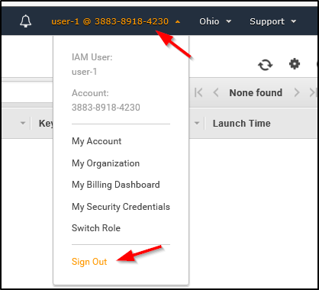

1. Paste the **IAM users sign-in** link into your private window and press **Enter**.

This links should be in your text editor.

1. Sign-in with:
   * **IAM user name:** user-2
   * **Password:** <the custom password you created while creating the user>
2. In the **Services** menu, click **EC2**.
3. In the navigation pane on the left, click **Instances**.

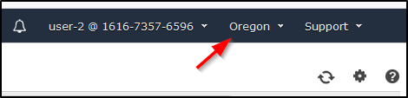

1. In the **Instance state** menu, choose **Stop instance**. (**SKIP**)
2. In the **Stop Instance** window, click **Stop**. (**SKIP**)
3. At the **Stop instances** window, click **Cancel**. (**SKIP**)

Next, check if user-2 can access Amazon S3.

1. In the **Services**, click **S3**.

You will receive an  **Error Access Denied** because user-2 does not permission to use Amazon S3.

You will now sign-in as **user-3**, who has been hired as your Amazon EC2 administrator.

1. Sign user-2 out of the **AWS Management Console** by configuring the following:
   * At the top of the screen, click **user-2**
   * Click **Sign Out**

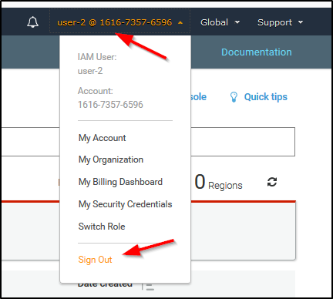

1. Paste the **IAM users sign-in** link into your private window and press **Enter**.
2. Paste the sign-in link into your web browser address bar again. If it is not in your clipboard, retrieve it from the text editor where you stored it earlier.
3. Sign-in with:
   * **IAM user name:** user-3
   * **Password:** <the custom password you created while creating the user>
4. In the **Services** menu, click **EC2**.
5. In the navigation pane on the left, click **Instances**.

As an EC2 Administrator, you should now have permissions to Stop the Amazon EC2 instance.

1. In the **Instance state** menu, choose **Stop instance**. (**SKIP**)
2. In the **Stop instance** window, click **Stop**. (**SKIP**)
3. Close your private window.

   **YOU CAN DELETE YOUR USERS AND GROUPS NOW**

**Lab Complete**

Congratulations! You have completed the lab.

1. Click End Lab at the top of this page and then click **Yes** to confirm that you want to end the lab.

A panel will appear, indicating that "DELETE has been initiated... You may close this message box now."

1. Click the **X** in the top right corner to close the panel.

**Conclusion**

 Congratulations! You now have successfully:

* Explored pre-created IAM users and groups
* Inspected IAM policies as applied to the pre-created groups
* Followed a real-world scenario, adding users to groups with specific capabilities enabled
* Located and used the IAM sign-in URL
* Experimented with the effects of policies on service access

**Additional Resources**

* [AWS Training and Certification](https://aws.amazon.com/training/)
* [For more information about AWS IAM](https://aws.amazon.com/iam/)